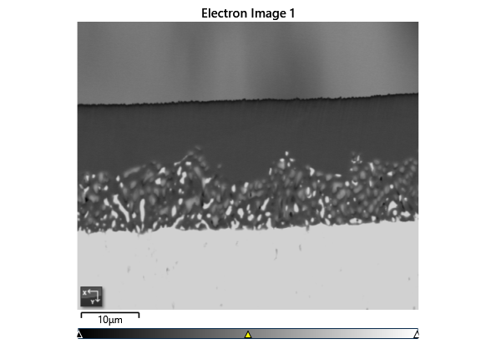

Settings

|  |  |
| --- | --- |
| Accelerating Voltage | 20.00 kV |
| Specimen Tilt (degrees) | 70.00 ° |
| Hit Rate | 80.16 % |
| Speed of Acquisition | 24.35 Hz |

Phases for Acquisition

|  |  |  |  |  |  |  |  |  |
| --- | --- | --- | --- | --- | --- | --- | --- | --- |
| Phase | a | b | c | Alpha | Beta | Gamma | Space Group | Database |
| Iron bcc (old) | 2.87 Å | 2.87 Å | 2.87 Å | 90.00 ° | 90.00 ° | 90.00 ° | 229 | HKL |
| Iron fcc | 3.66 Å | 3.66 Å | 3.66 Å | 90.00 ° | 90.00 ° | 90.00 ° | 225 | HKL |
| Nickel | 3.52 Å | 3.52 Å | 3.52 Å | 90.00 ° | 90.00 ° | 90.00 ° | 225 | OINA Phases |

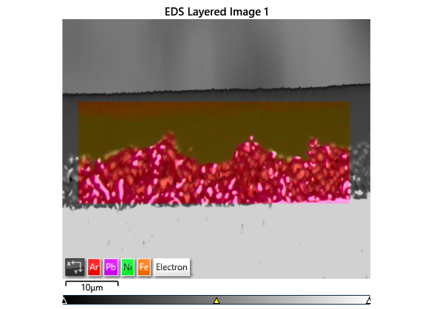

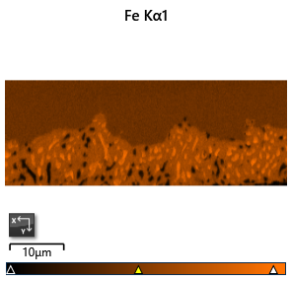

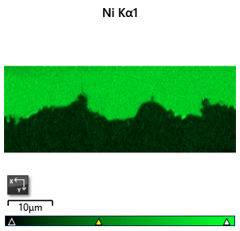

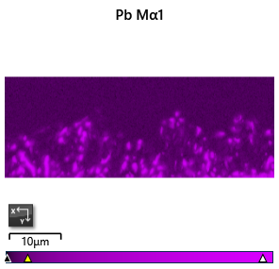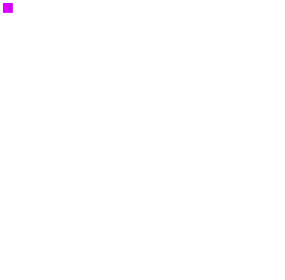

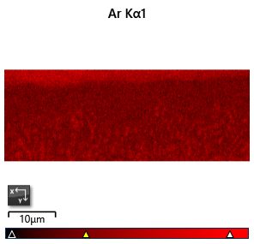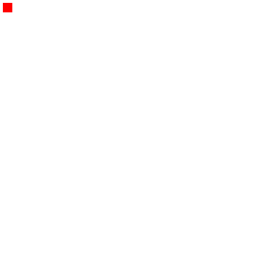

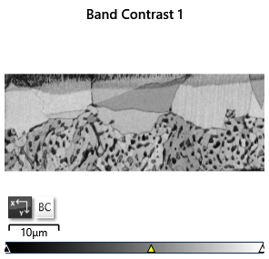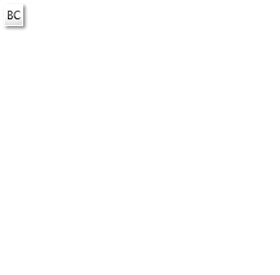

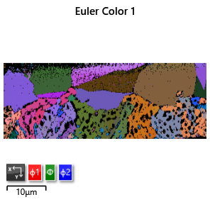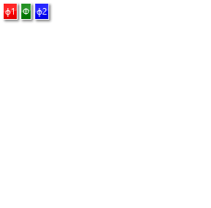

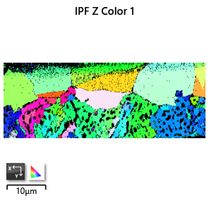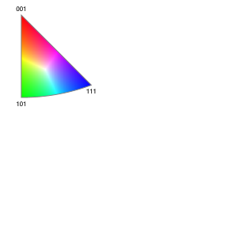

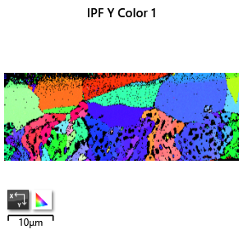

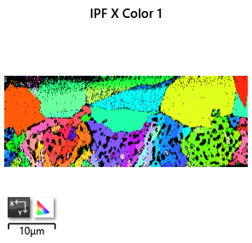

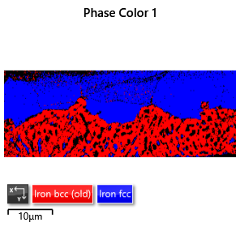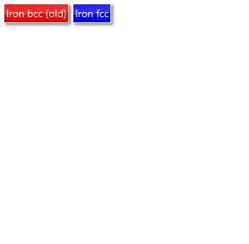

Phase Fraction

|  |  |  |  |  |  |  |  |  |  |  |
| --- | --- | --- | --- | --- | --- | --- | --- | --- | --- | --- |
| Phase Name | Phase Fraction (%) | Phase Count | Mean Band Contrast | Standard Deviation Band Contrast | Min Band Contrast | Max Band Contrast | Mean MAD | Standard Deviation MAD | Min MAD | Max MAD |
| Iron bcc (old) | 35.99 | 14474 | 93.72 | 12.65 | 21.00 | 120.00 | 0.80 | 0.22 | 0.18 | 2.00 |
| Iron fcc | 44.17 | 17767 | 99.05 | 13.04 | 24.00 | 123.00 | 0.72 | 0.22 | 0.15 | 2.00 |
| Nickel | 0.00 | 0 | 0.00 | 0.00 | 0.00 | 0.00 | 0.00 | 0.00 | 0.00 | 0.00 |
| Zero Solutions | 19.84 | 7980 | 54.58 | 24.27 | 0.00 | 133.00 |  |  |  |  |